Cody Gunter

Deep Learning

SMU

05/28/2022

This analysis was done attempting to predict at a 75% accuracy rate whether or not non-profit charities will be successful in reaching their goal. When we are lending money to nonprofits, we want to lend it to capable hands and building an accurate model determining their success will minimize our opportunity cost.

The target for my model was whether or not the organization was successful in reaching their goal. Features of the model included the type of application, affiliated sector of the industry, organization classification, use case for funding, the amount asked for, and income. The organization’s name was not considered for the model as this information doesn’t help us in determining likelihood of success as the name doesn’t reflect anything about the organization other than its name. The EIN (id) column was recommended to be dropped, but I kept it as it did help the model slightly.

My most accurate model reached a 73.15% accuracy rate consisting of 5 layers. The first layer contains 50 nodes, with following layers of 22, 12, 6, and 1 being the output layer.

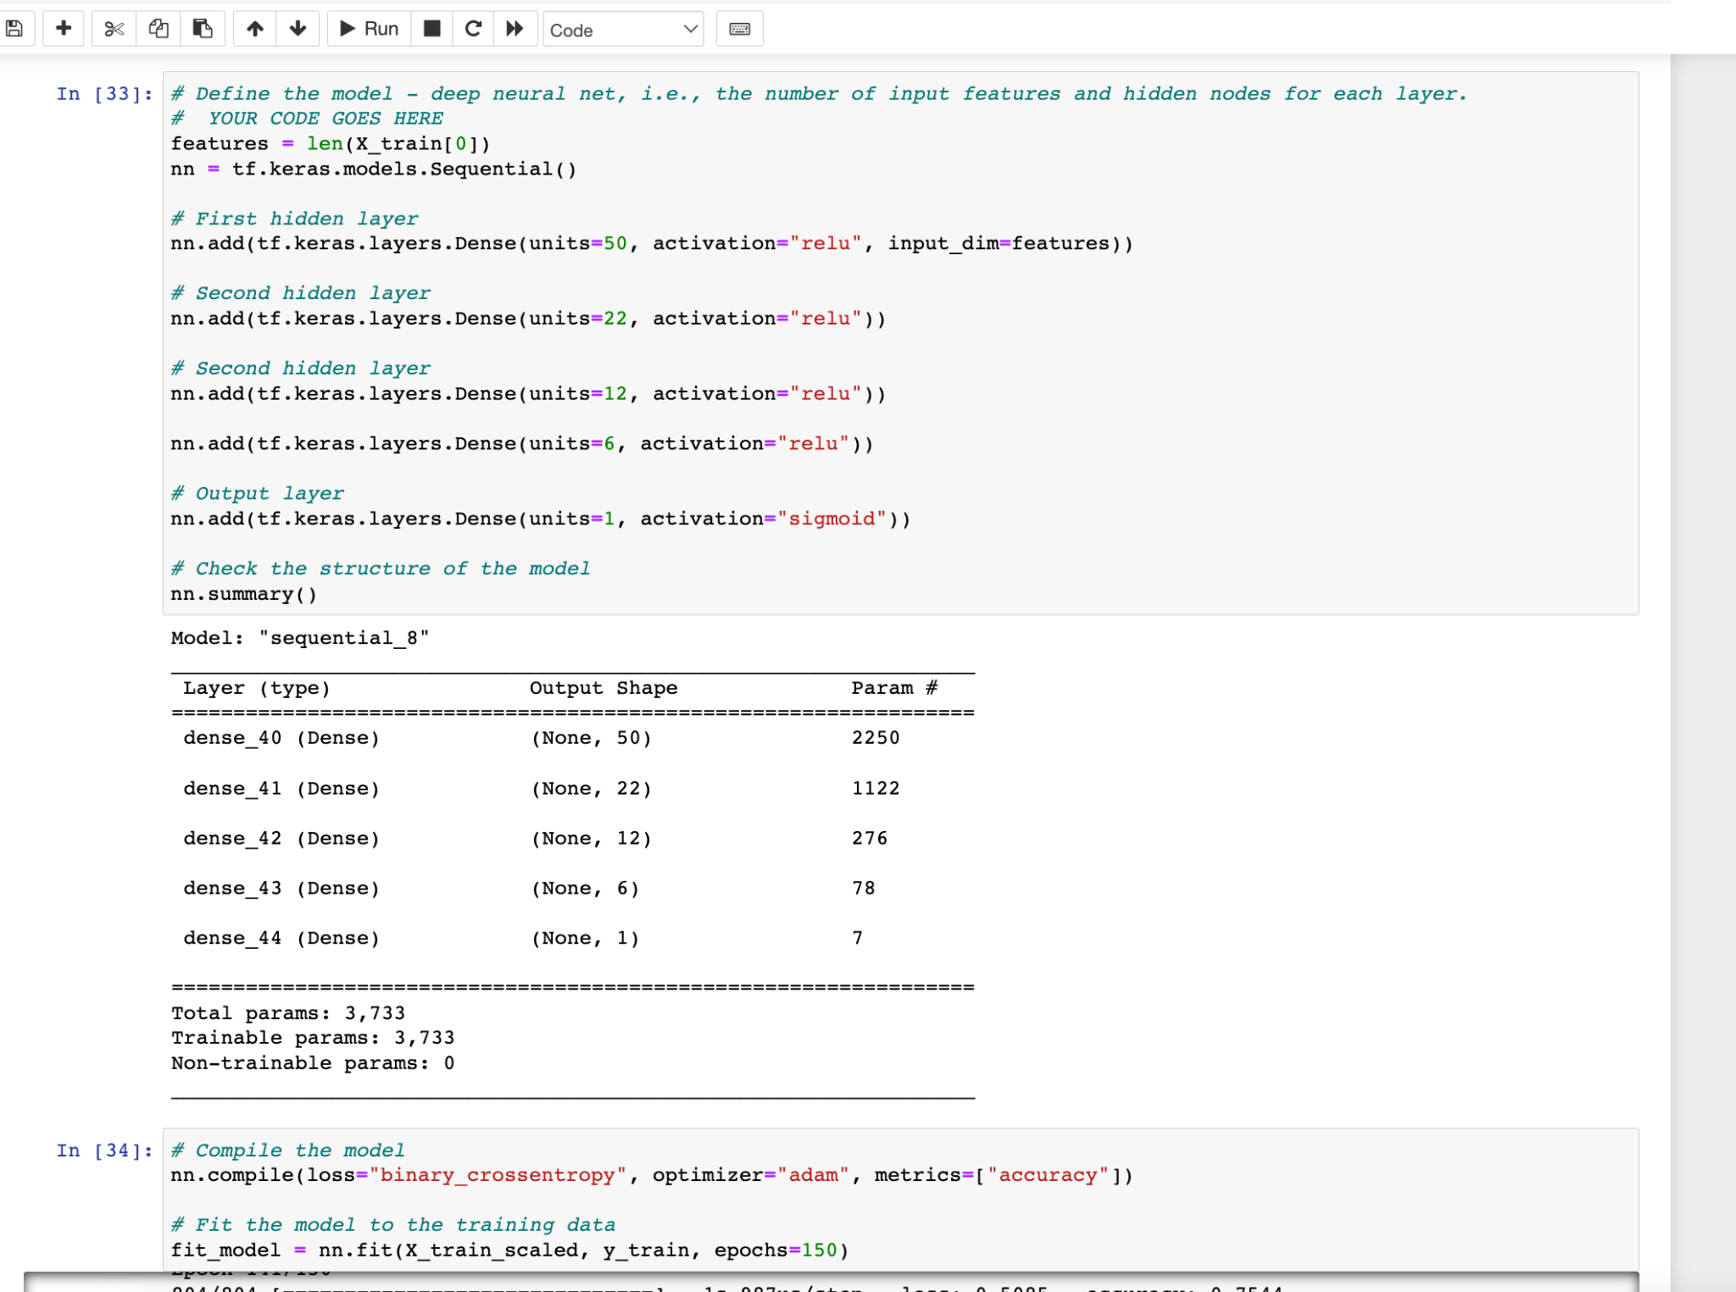

With this final model I was still not able to hit the 75% mark. My first models reached about 72.3% accuracy and crossing the 73% threshold proved to be a challenge. Initially, I added layers and neurons to the model with minimal success. Then I removed the status and special consideration columns as the vast majority of the features’ values were the same. This didn’t prove to be successful, diminishing the model. After changing the features, changing the cutoff value for the classification and application type, affecting the value counts of the other value in each feature didn’t prove to be effective either. Keeping the relu activation for the hidden layers and sigmoid activation for the output layer proved to me the most successful. Keeping the classification and application type cutoff at sub 700, I then did not remove the EIN column as that slightly improved the model. With the EIN feature included, tinkering with the number of layers, nodes, and epochs were the final steps in an attempt of bettering the model.